Practice Worksheet
Meet your team leader

Instructions:
I. Look at the organizational chart. Put the employee names in the correct place according to their position. One new position is already included in the chart.

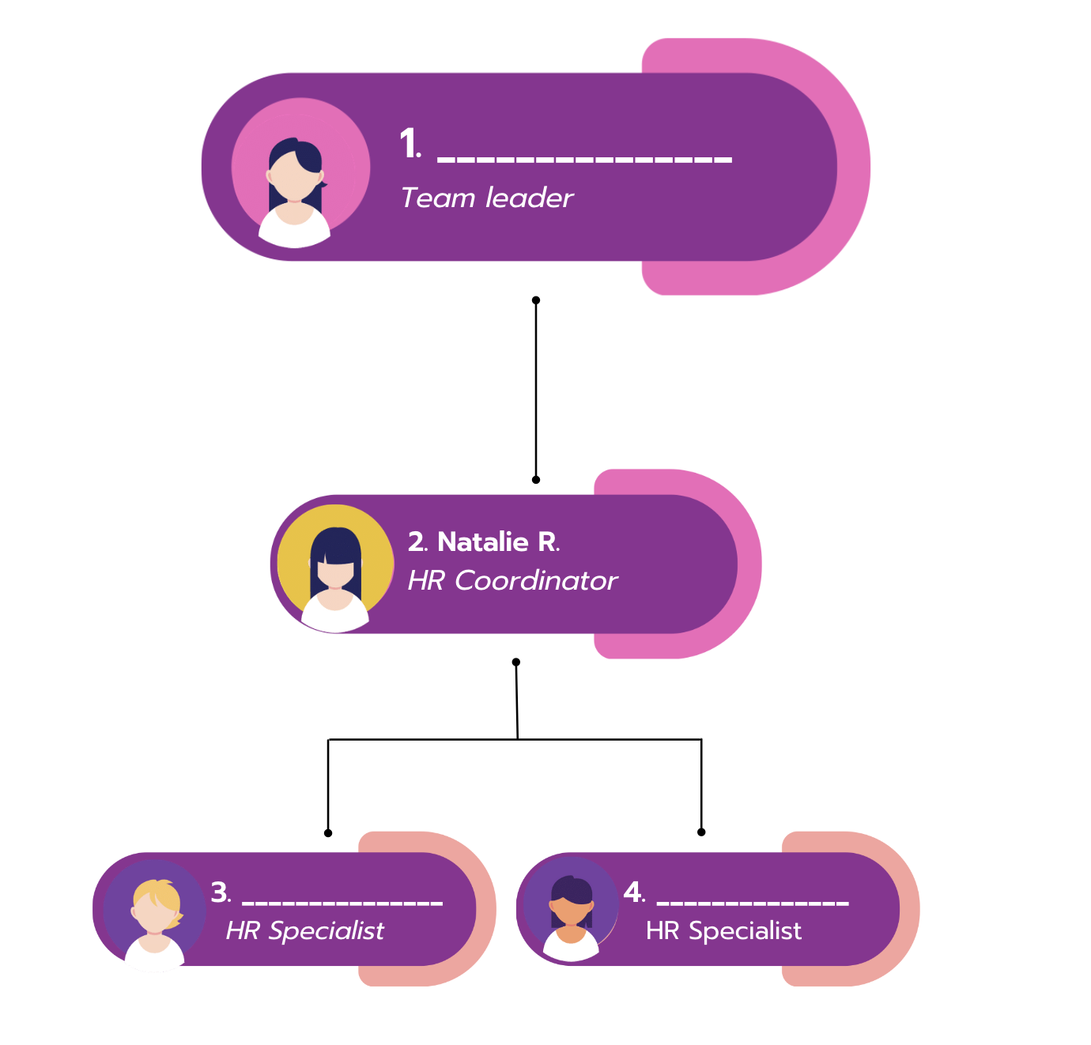


Answer Key:
- Sandra
- Natalie
- Adam

- Veronica

